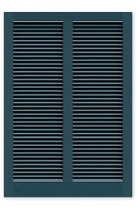

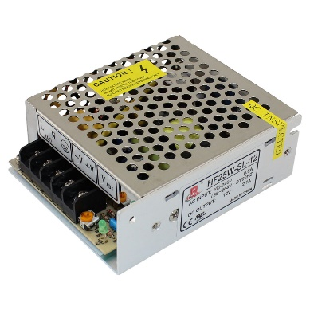

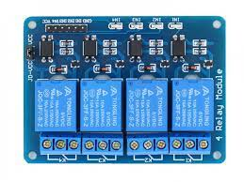

**Prototype Greenhouse**

* Airflow Control System

